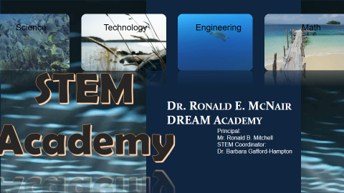 |  | STEM Meeting  - Information Time  - August
Being in STEM has GREAT Benefits! |  | In This Issue

How does STEM benefit your child
by Dominique Waldron

STEM scares many students because it is perceived as being too difficult and – tragically – boring. Clear up the misconceptions and check out these benefits of a STEM education.
The truth is that STEM encompasses the most engaging, hands-on subjects in our schools. Strong STEM skills lead to more beautiful art, more engrossing performances, and more polished productions.
STEM classes develop those soft skills that so many careers need, and so many students lack – skills like communication, problem solving, critical thinking, creativity, and data analysis.
In fact, non-STEM fields heavily recruit graduates with STEM degrees because they possess these skills that students from other majors have not developed.
Here are some other benefits of a STEM education you may have never considered:

1. It helps you stay current.
In a technology-based society, technology is forever changing. It’s also used in almost every aspect of our lives. As work places change with updated software, and office equipment and machinery become more advanced, STEM knowledge is vital. Keeping up with technology, not the Kardashians, is incredibly important.

2. It allows you to be innovative.
Someone created an app that allows you to take a picture of a piece of clothing and finds similar looks throughout the web.
Just think of the latest device you have in your hand or at the top of your wish list. STEM helps to transform new ideas into the best inventions.

3. It helps you make a difference.
Building that shelter, finding that cure, inventing the best way for people to communicate, or helping people overcome financial obstacles makes a huge difference – and with a STEM education, you can make that happen.

4. It fosters – and benefits from – creativity.
Creativity is one of the many benefits of a STEM education.
Ironically, creativity is also the result of a STEM education! According to the NYTimes, James Michael Leake, director of engineering graphics at the University of Illinois, said that learning to make even rudimentary drawings is critical to development as an engineer. Design can help students understand how to effectively use the space within the structure.

5. It can get you a job in the beauty industry.
Without new innovative products hitting the shelves constantly, brands such as Cover girl and L’Oreal will not stay current and may lose business. This creates a lot of new opportunities for scientists to break into this industry. Just think – a product you design or create could help people feel more confident and comfortable in their own skin.

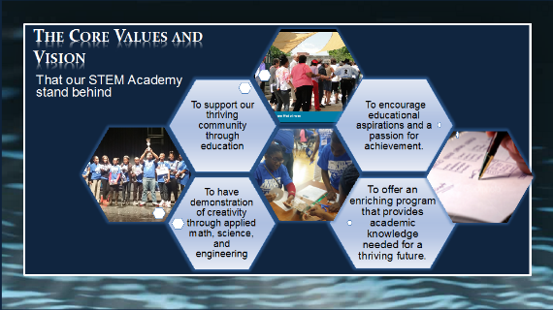
How does it benefit students now!
Aside from all of the wonderful benefits mentioned in the 1st article it also allows for the following benefits:
1. Students get to participate in all enhanced learning opportunities such as STEM speakers, projects, and field trips
2. Students get to participate in rigorous academia allowing them to be able to go to any educational program and be successful.
2. It allows students to leave Middle School with 3 Carnegie (high school) credits. This means that your student will have the opportunity to participate in early graduation if this track is maintained. Students can also participate in Move on When Ready. This program will allow them to graduate with an Associate’s Degree from an accredited University before they leave high school for free.
Things to know that will you’re your student be successful in the STEM program
Your student has built in math support. We offer a math based ELT to all students. In addition all STEM students have been placed in Math tools so that they can receive any additional help they may need. Finally, we have sought out (and continue to seek) the very best math and science educators so that our STEM students will be immersed in 21st century (and beyond) learning.
To be successful in the program students need to come in with the mindset that education is important. It is the great equalizer and our children deserve it! Now, to assist them with keeping an eye on their education we want all of our program students to have access to the following sites:
Infinite Campus – parents must sign up first!
https://campus.dekalb.k12.ga.us/campus/portal/dekalb.jsp
But after that students will be able to log in and check grades on a regular bases. This can elevate any failures because they can ask their teachers for some time to discuss their grades afterschool or during down time.
Verge – Students will use the same password from infinite campus and office 365 for this site.
https://dekalb.itslearning.com/
USAtest Prep – Science and Social studies use this for tutorials, assessments and activities.
https://www.usatestprep.com/member-login
Study Island – Math use this for tutorials, assessments, and activities.
http://www.studyisland.com/login
Launch Pad is our go to point for all online resources. It can be found on the DeKalb County School District website at the bottom.

